Ex-no: 12 M . Rohith
07-05-2024 3122 21 5001 085

UCS 2611 Internet Programming Lab
Exercise 12. Full Stack Todo Web Application using ReactJS, Node and MongoDB

Develop a Todo Web Application that enables the user to maintain and keep track of their Todo list [CO2, K3]
Draw a diagram depicting the design flow of your project with necessary components, endpoints and collections
Application has the following:
- Front end to provide necessary requests using ReactJS
- Maintain the details in MongoDB
- Define necessary functionalities in the required components and endpoints in node server to display the Todo application like below:

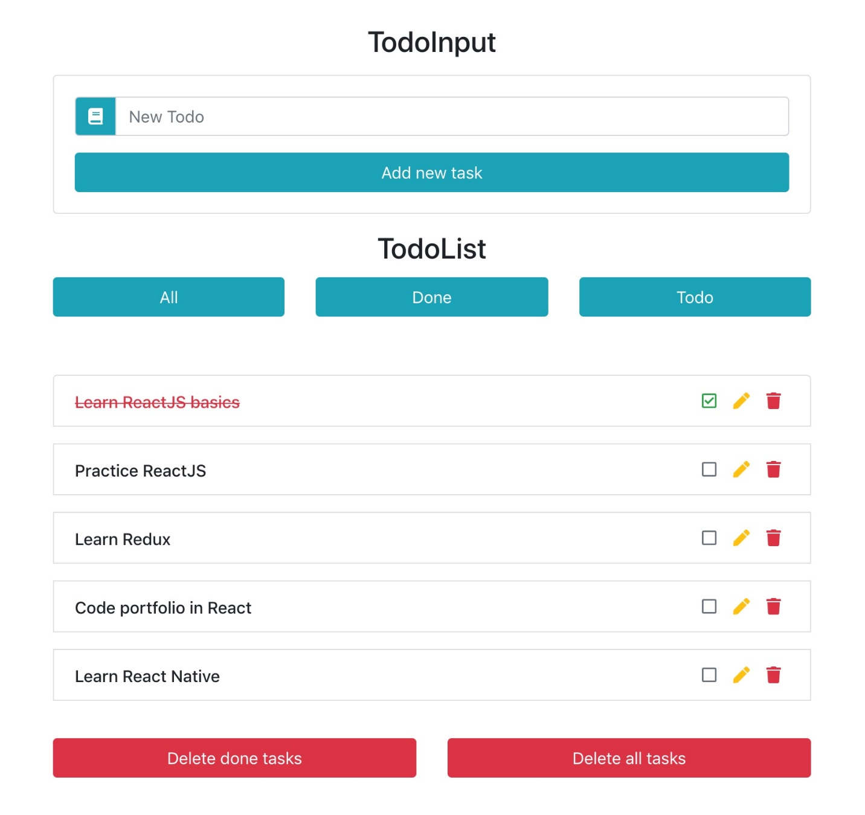

Best Practices to be followed:
- Design before coding
- Incremental coding
- Usage of proper naming convention
- Usage of Comments to the code
- Indentation of code

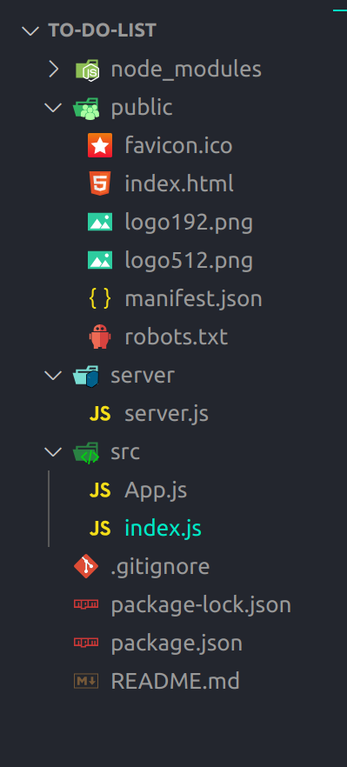
Hierarchy:

Program code:

server.js

const express = require('express');
const bp = require("body-parser");
const cors = require('cors');
const { MongoClient } = require('mongodb');

const server_name = express();
server_name.use(cors());
server_name.use(bp.json());

// Database Config
const client = new MongoClient("mongodb://localhost:27017");
client.connect();
const db = client.db("learning");
const usersCollection = db.collection("todo");
const completedCollection = db.collection("completed");
console.log("Database Connected Successfuly....");

// AddTask END POINT
async function AddTask(newTask){
const result = await usersCollection.insertOne({ task: newTask });
console.log("Task inserted successfully:", result.insertedId);
}
server_name.post('/addTask', (req, res)=>{
const data = req.body;

AddTask(data.task);

res.status(200).send("success");
});

// ReadTask END-POINT
async function ReadTask(){
console.log('read function is called');
try {
const cursor = usersCollection.find({});
const tasks = await cursor.toArray();
const result = [];
for(var i=0; i<tasks.length; i++)
result.push(tasks[i].task)

return result;
} catch (error) {
console.error("Error reading tasks:", error);
return [];
}
}
server_name.get('/readTask', async (req, res) => {
try {
const tasks = await ReadTask();
console.log(tasks);
res.status(200).json({task:tasks});
} catch (error) {
res.status(500).send("Internal server error");
}
})

// DeleteTask END-POINT
async function DeleteTask(pos){
try {
const tasks = await ReadTask();
if (pos >= 0 && pos < tasks.length) {
const taskToDelete = tasks[pos];
await usersCollection.deleteOne({ task: taskToDelete });
} else {
console.log("Invalid position:", pos);
}
} catch(error){
console.error('Error in deleting record in DB:', error);
}
}

server_name.post('/deleteTask', (req, res)=>{
try{
const data = req.body;

DeleteTask(data.index);

res.status(200).send("success");
}catch(error){
res.status(402).send("Delete Error");
}
})

// MoveTask END-POINT
async function MoveTask(pos) {
try {
const tasks = await ReadTask();
if (pos >= 0 && pos < tasks.length) {
const taskToMove = tasks[pos];
const result = await completedCollection.insertOne({ task: taskToMove });
console.log("Task moved to completed collection:", result.insertedId);
await DeleteTask(pos);
} else {
console.log("Invalid position:", pos);
}
} catch (error) {
console.error("Error moving task:", error);
}
}

server_name.post('/moveTask', (req, res) =>{
try {
const data = req.body;
const index = data.index;

MoveTask(index);

res.status(200).send("success");
} catch (error) {
console.error("Move Error:", error);
res.status(500).send("Move Error");
}
})

// ReadCompletedTask END-POINT
async function ReadCompletedTask() {
try {
const cursor = completedCollection.find({});
const tasks = await cursor.toArray();
const result = tasks.map(task => task.task);
return result;
} catch (error) {
console.error("Error reading completed tasks:", error);
return [];
}
}

server_name.get('/readCompletedTask', async (req, res) => {
try {
const completedTasks = await ReadCompletedTask();
res.status(200).json({ completedTasks });
} catch (error) {
console.error("Error fetching completed tasks:", error);
res.status(500).send("Internal server error");
}
});

server_name.listen(4000, ()=>{
console.log("Server Listening on http://localhost:4000");
})

App.js

import { useState, useRef, useEffect} from "react";
const SERVER_URL = "http://localhost:4000"
function App() {

const userInput = useRef('');
const [tasks, setTasks] = useState([]);
const [completedTasks, setCompletedTasks] = useState([]);

const addTask = () => {
console.log("AddTask() Function is called");
const newTask = userInput.current.value;
console.log("New Task Added: " + newTask);

// ADD API "http://localhost:4000/addTask"
fetch(SERVER_URL+'/addTask', {
method: 'POST',
headers: {
'Content-Type': "application/json"
},
body: JSON.stringify({ task: newTask })
})
.then(res => res.text())
.then(data => readTask())
.catch(error => console.log("ADD ERROR: " + error));

// readTask();
}

// READ API "http://localhost:4000/readTask"
const readTask = () =>{
console.log("ReadTask() function is called");
fetch(SERVER_URL+"/readTask", {
method: 'GET'
})
.then(res => res.json())
.then(data => {
console.log(data.task);
setTasks(data.task);
})
.catch(e => console.log("READ ERROR: " + e));
}

// Delete API "http://localhost:4000/deleteTask"
const deleteTask = (taskIndex) =>{
console.log("DeleteTask() function is called");
console.log("data: " + taskIndex);
fetch(SERVER_URL+'/deleteTask', {
method: "POST",
headers:{
"Content-Type":"application/json"
},
body: JSON.stringify({index:taskIndex})
})
.then(res => res.text())
.then(data => readTask())
.catch(error => console.log("DELETE ERROR: " + error));
}

// Move API "http://localhost:4000/moveTask"
const moveTask = (taskIndex) =>{
console.log("DeleteTask() function is called");
console.log("data: " + taskIndex);
fetch(SERVER_URL+'/moveTask', {
method: "POST",
headers:{
"Content-Type":"application/json"
},
body: JSON.stringify({index:taskIndex})
})
.then(res => res.text())
.then(data => readTask())
.catch(error => console.log("MOVE ERROR: " + error));
}

const readCompletedTask = () => {
fetch(SERVER_URL + "/readCompletedTask")
.then(res => res.json())
.then(data => {
console.log(data.completedTasks);
setCompletedTasks(data.completedTasks);
})
.catch(e => console.log("READ COMPLETED ERROR: " + e));
};

useEffect(() => {
readTask();
readCompletedTask();
}, []);

const style = {
input: {
padding: '12px',
fontSize: '20px',
width:"300px"
},
btn: {
padding: '10px',
fontSize: '20px',
fontWeight: "bold",
},
displayTask: {
marginTop: "25px",
marginLeft: "25px",
fontSize: '22px',
textAlign:'left',
},
taskBtn: {
border: '0',
borderRadius:'5px',
marginLeft: '10px',
padding: '7px',
},
taskStyle: {
padding: '10px',
backgroundColor: 'lightblue',
margin: '2px',
borderRadius:'12px',
},
}

return (
<div style={{textAlign:"center", padding:"5px"}} >
<input type="text" ref={userInput} placeholder='Enter Your New Task' style={style.input} /> <button type="submit" onClick={addTask} style={style.btn}> Add Task</button>
<h2> --- Your ToDo Task --- </h2>
<section id="todo-task" style={style.displayTask}>
{tasks.map((task, index) => (
<div key={index} style={style.taskStyle}>
{task}
<span style={{float: "right"}}>
<button type="submit" onClick={()=>deleteTask(index)} style={style.taskBtn}><img src="https://cdn-icons-png.flaticon.com/512/6861/6861362.png" alt="delete" height="15px" /></button>
<button type="submit" onClick={() => moveTask(index)} style={style.taskBtn}> <img src="https://upload.wikimedia.org/wikipedia/commons/thumb/7/73/Flat_tick_icon.svg/512px-Flat_tick_icon.svg.png" alt="completed" height="15px" /></button>
</span>
</div>
))}
</section>
<h2> --- Completed Task --- </h2>
<section id="completed-task">
{completedTasks.map((task, index) => (
<div key={index} style={{backgroundColor:"lightgray", padding:'10px', borderRadius:'15px', margin:'10px', marginLeft:'25px', width:"100px"}}>
{task}
</div>
))}
</section>
</div>
);
}

export default App;

i

index.js

import React from 'react';
import ReactDOM from 'react-dom/client';
import App from './App';

const root = ReactDOM.createRoot(document.getElementById('root'));
root.render(
<React.StrictMode>
<App />
</React.StrictMode>
);

Output:

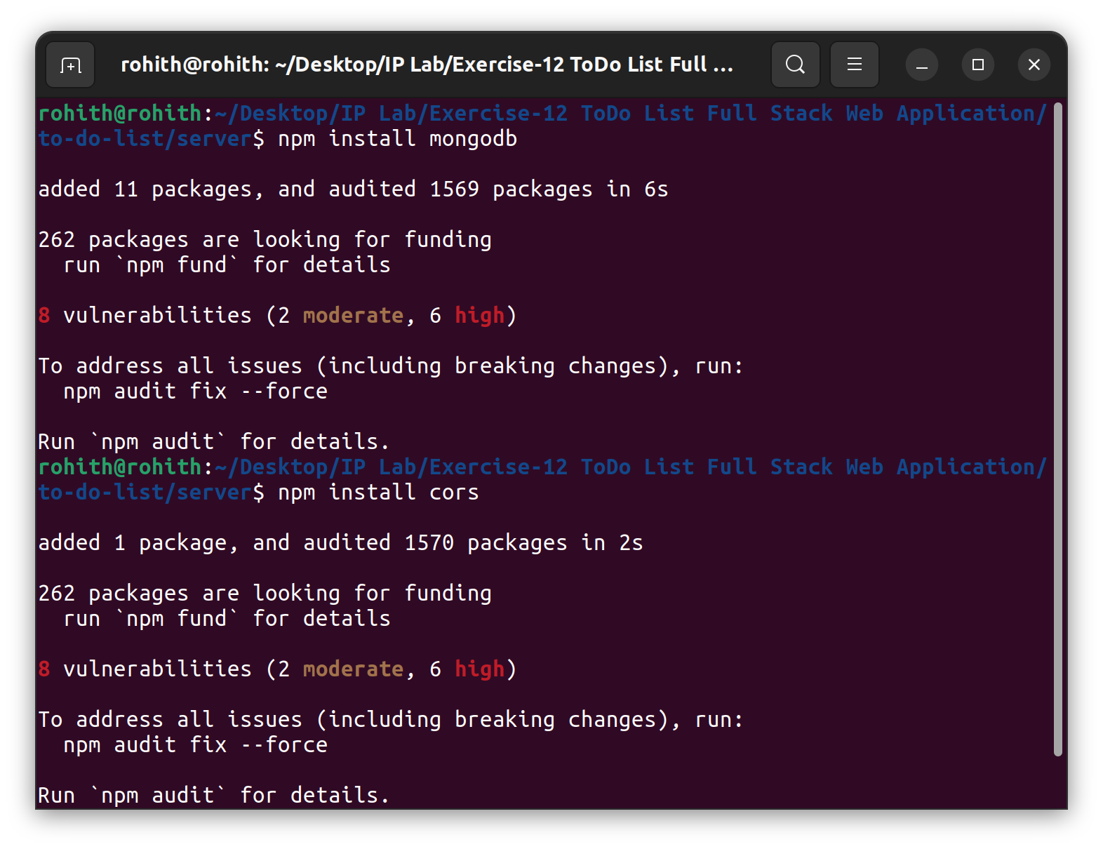
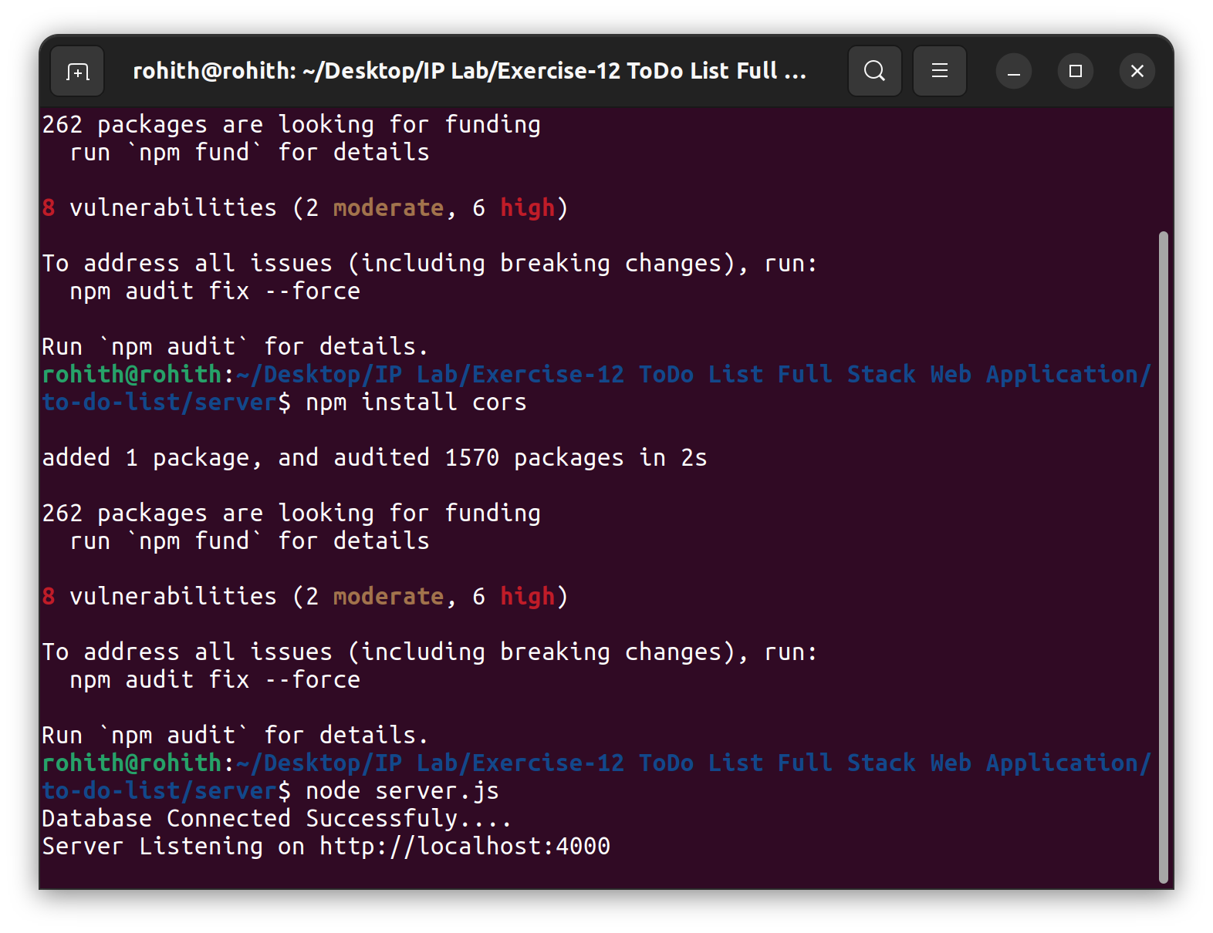

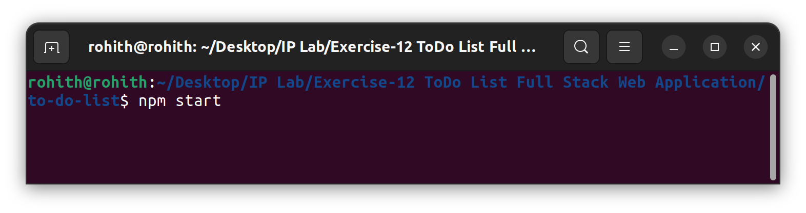

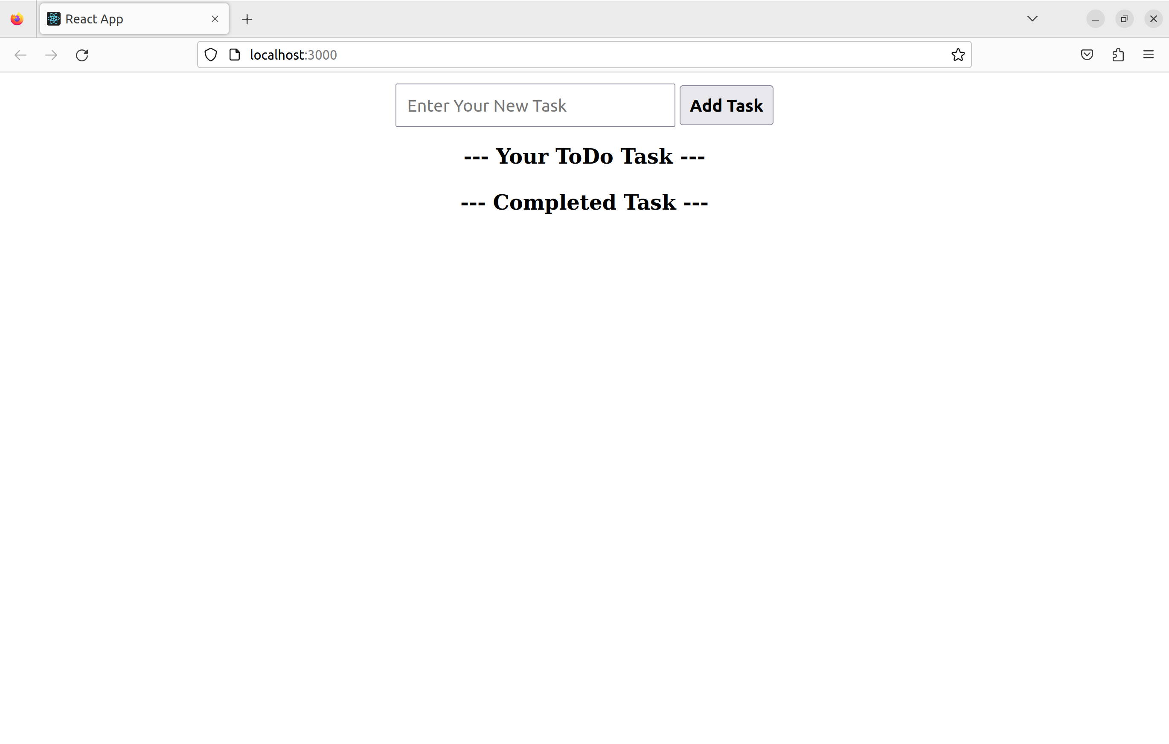

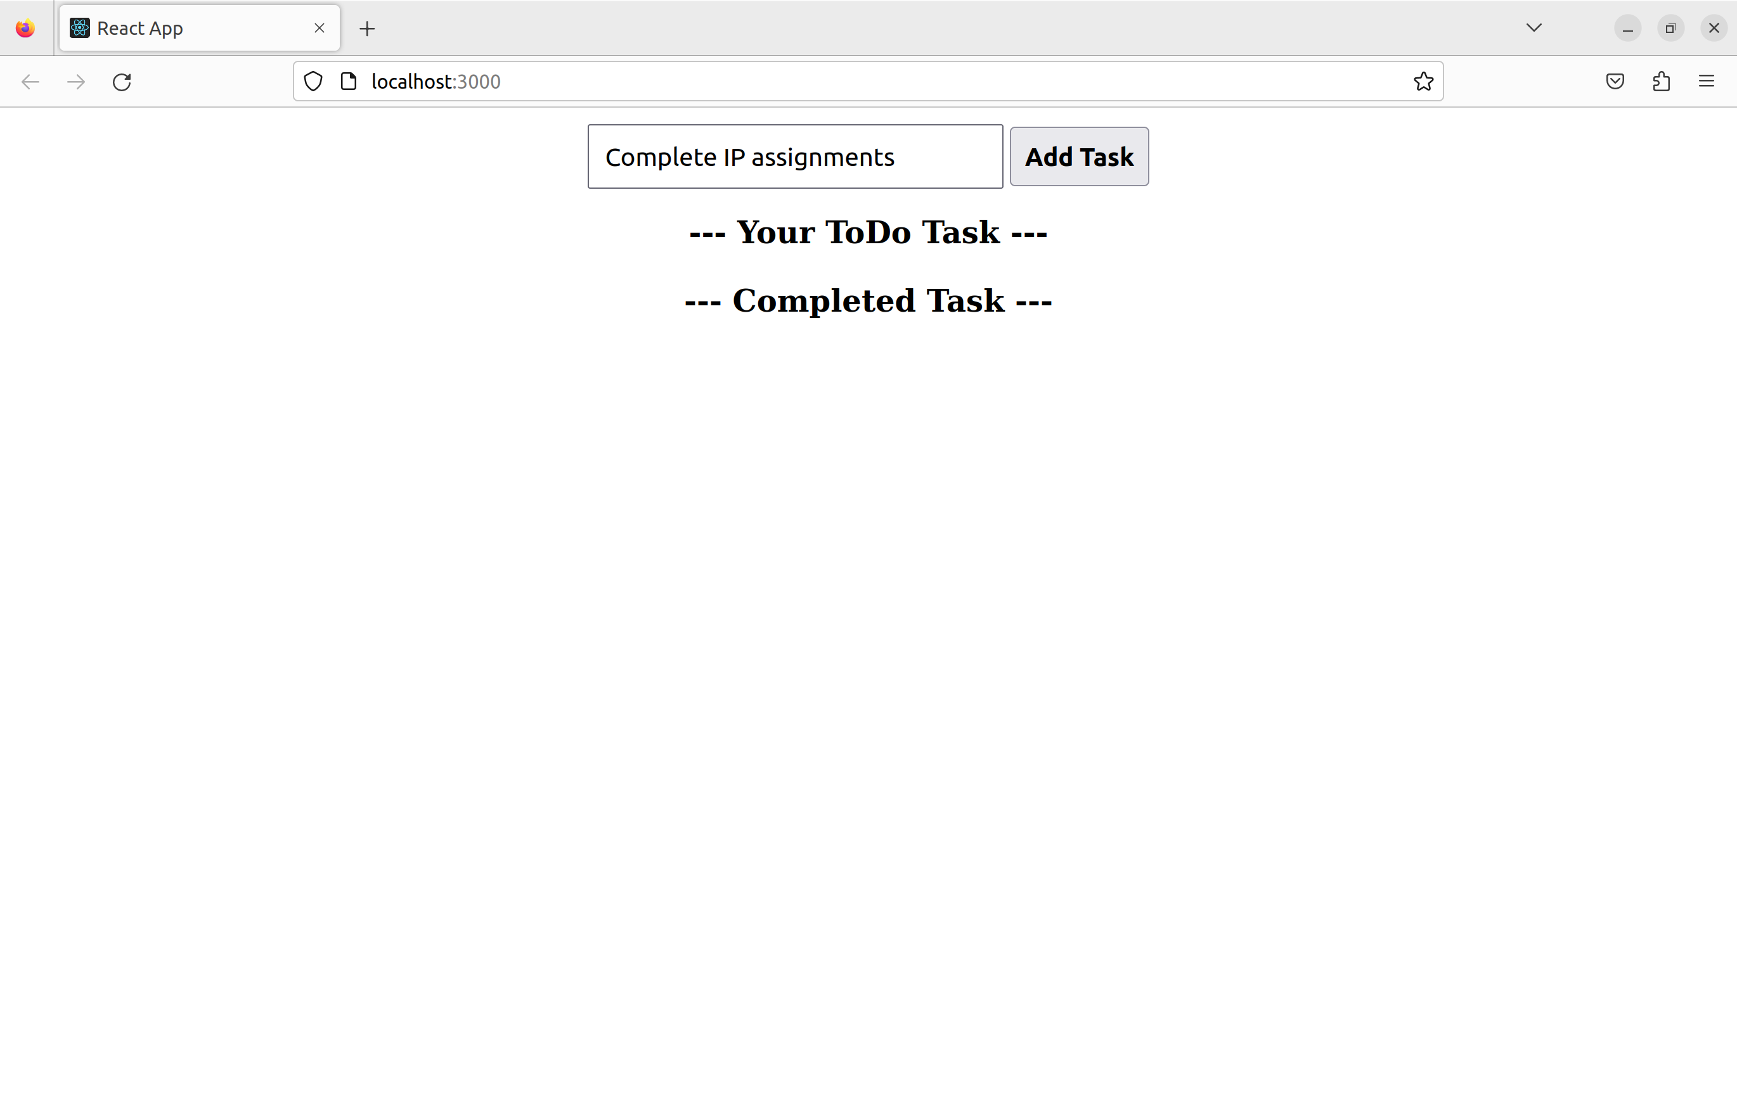
After typing the task, reload the page.

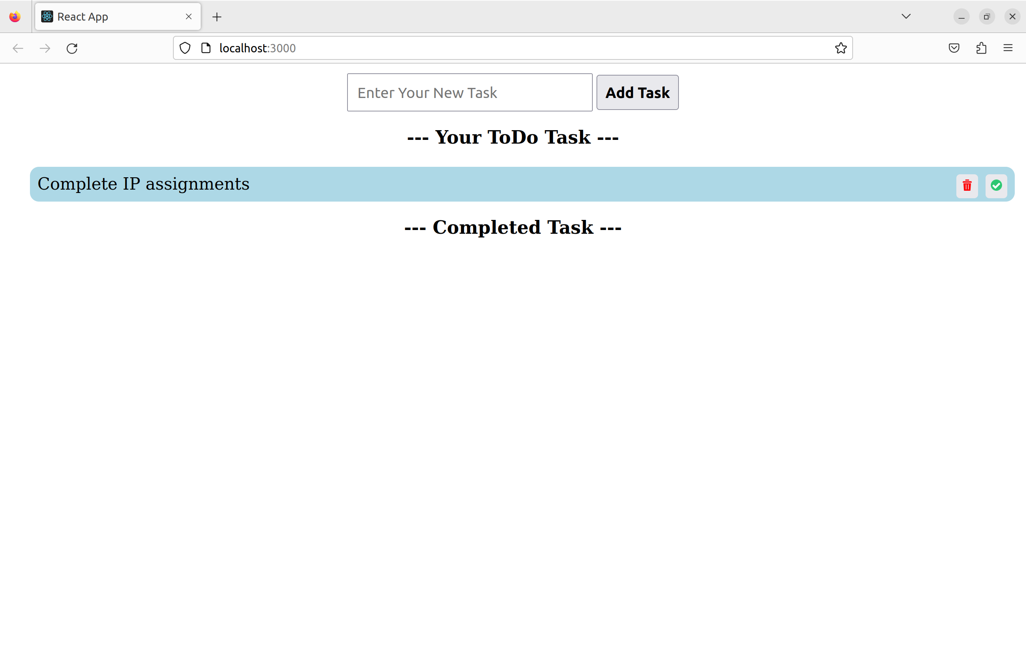

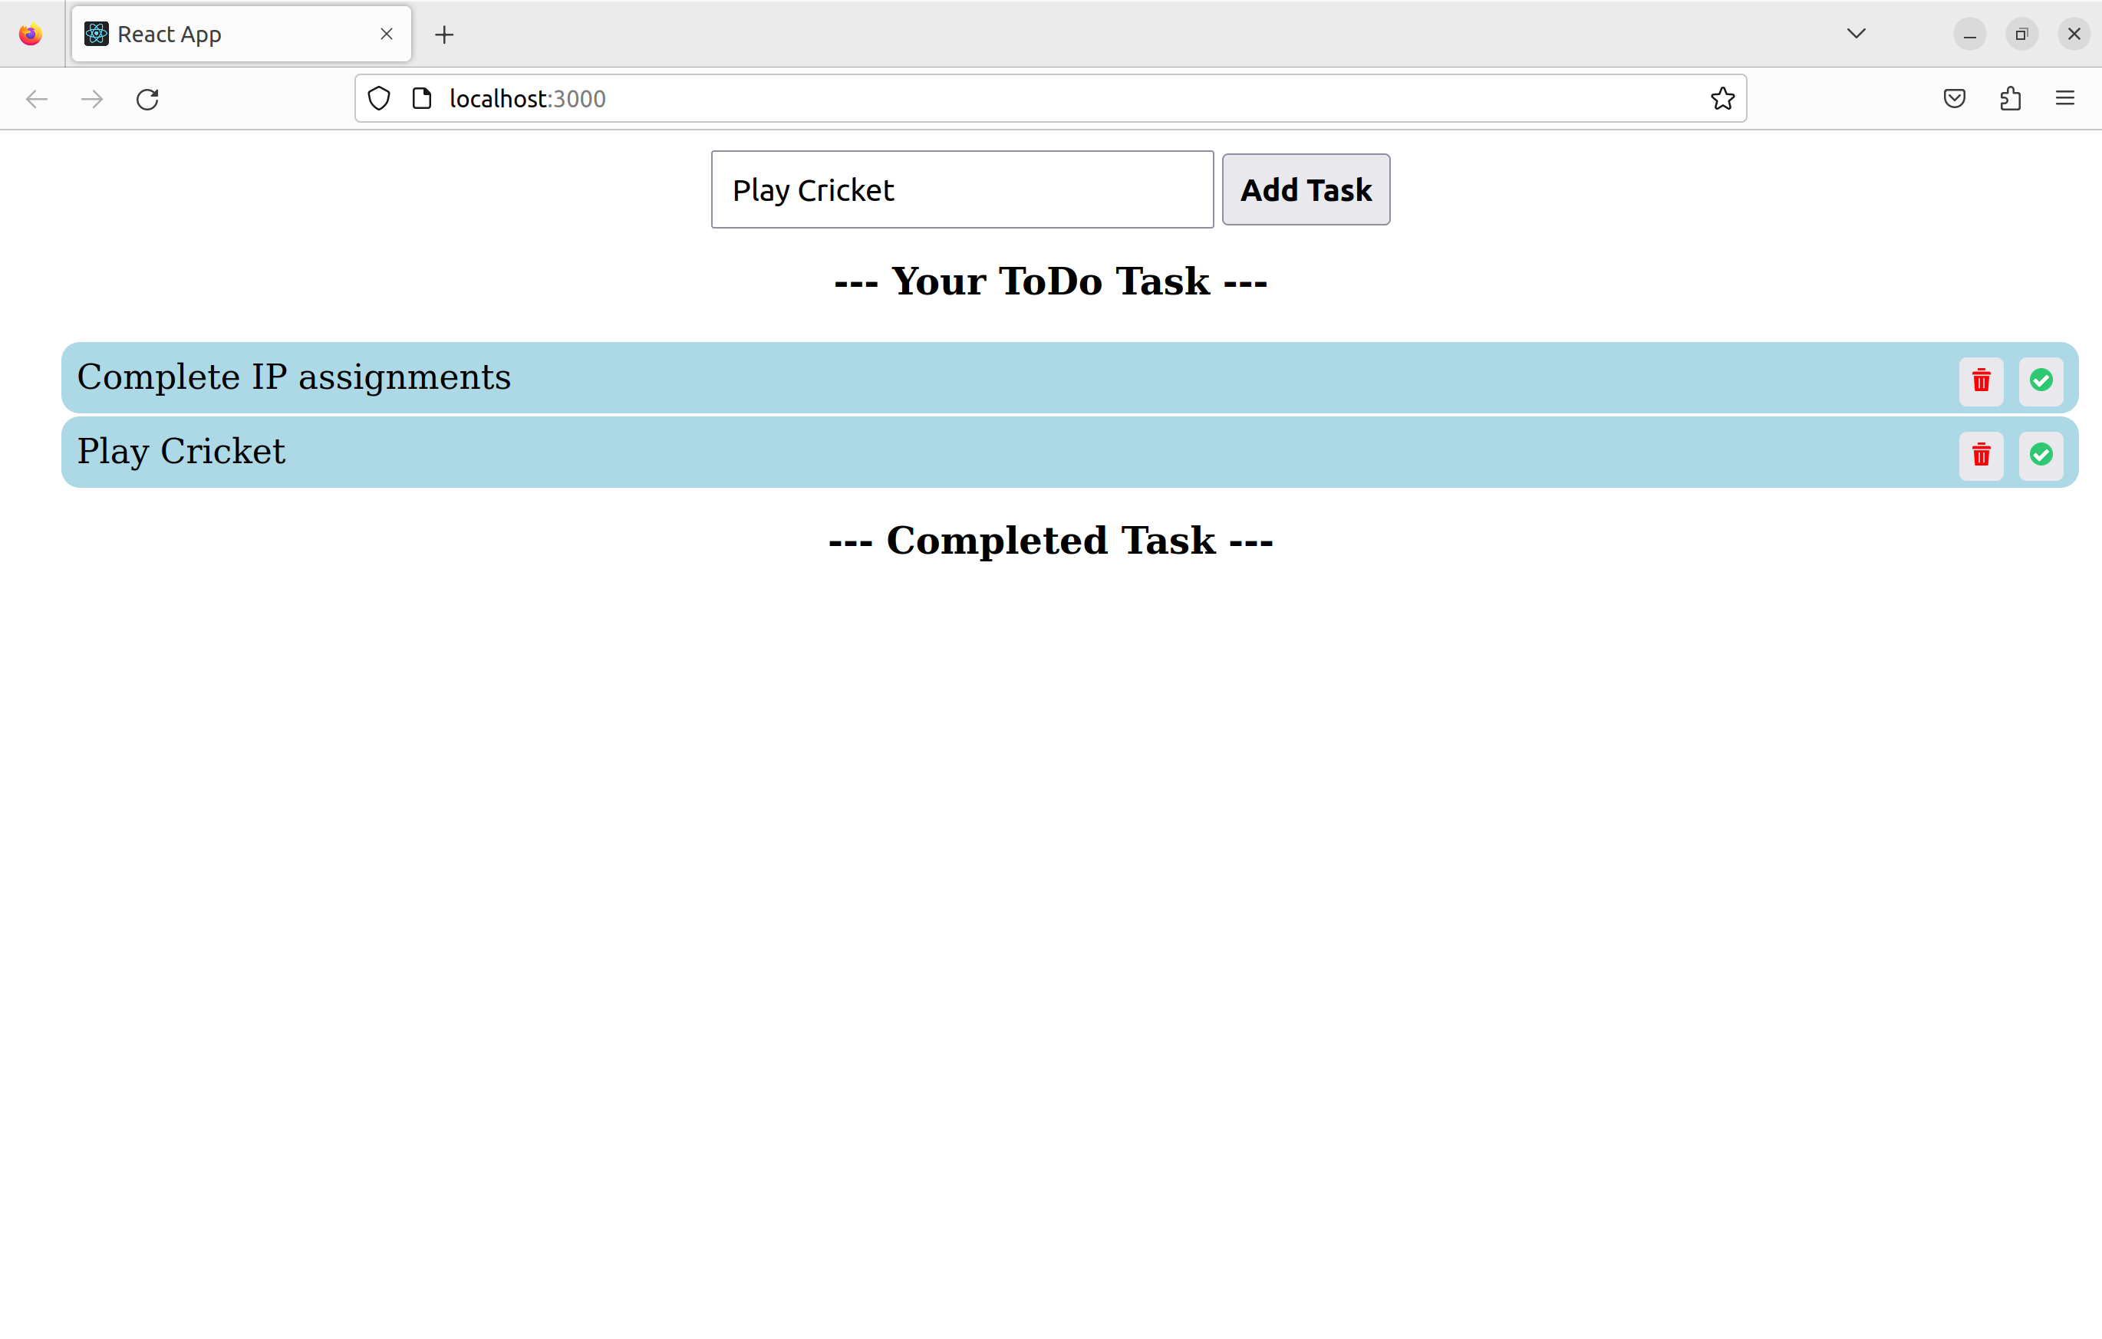
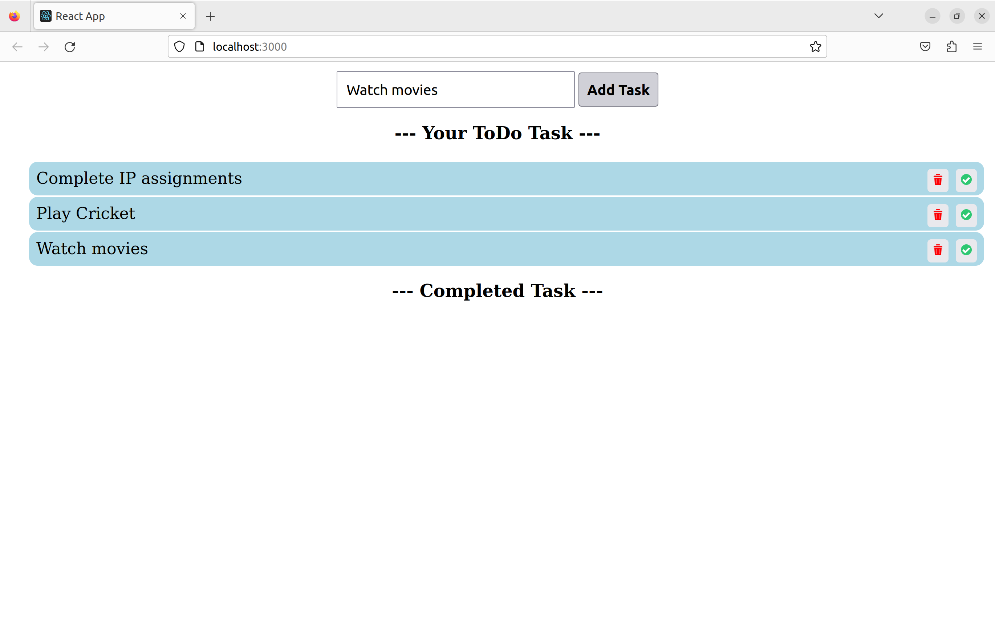

Once the task is completed by pressing the tick icon, reload the page.

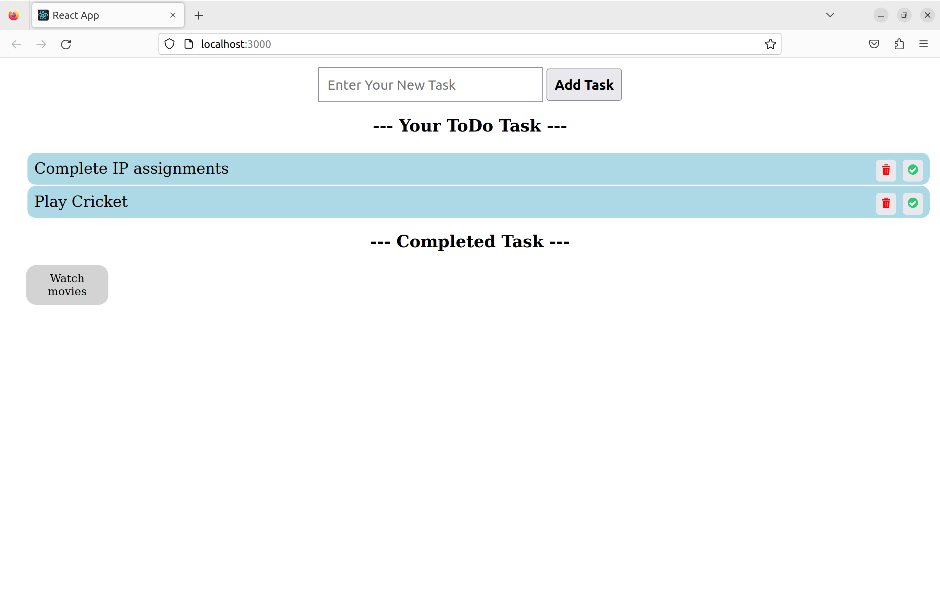

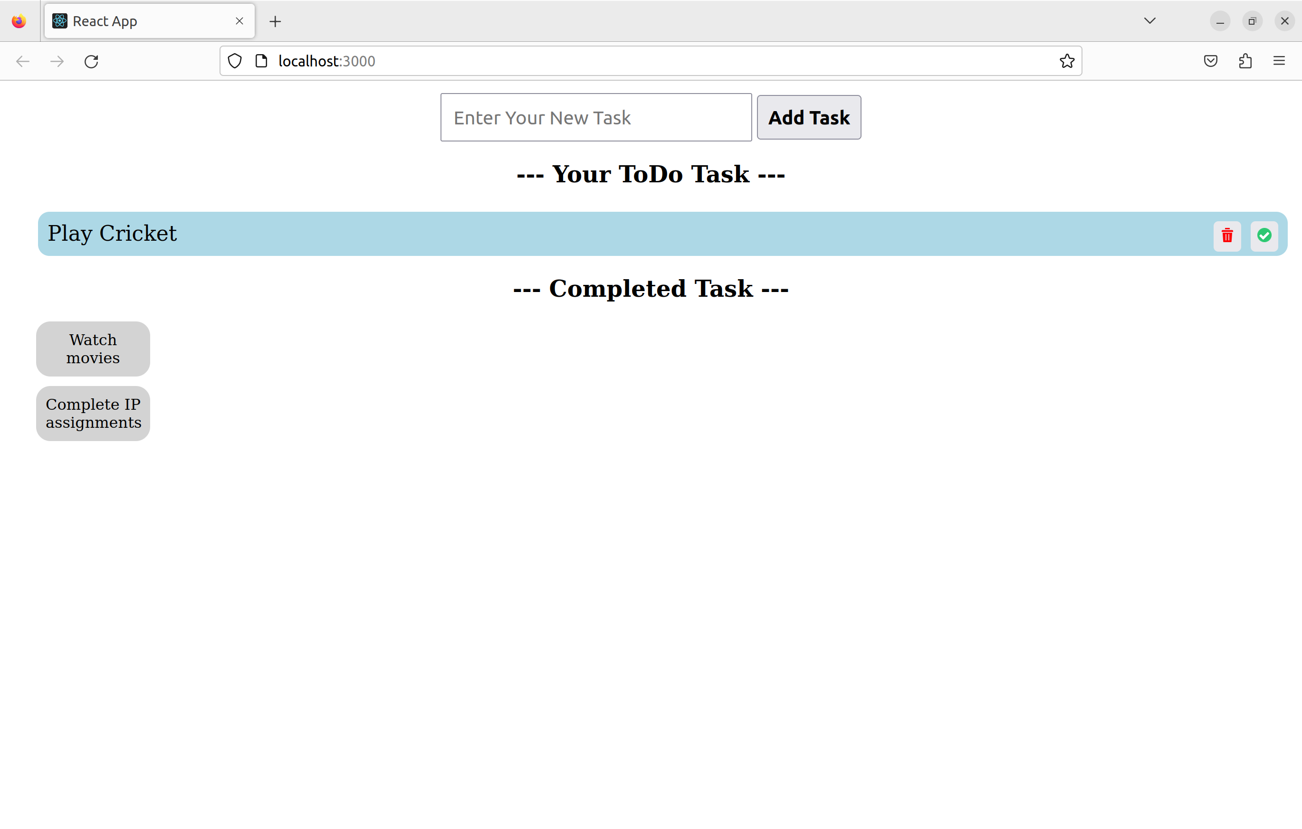
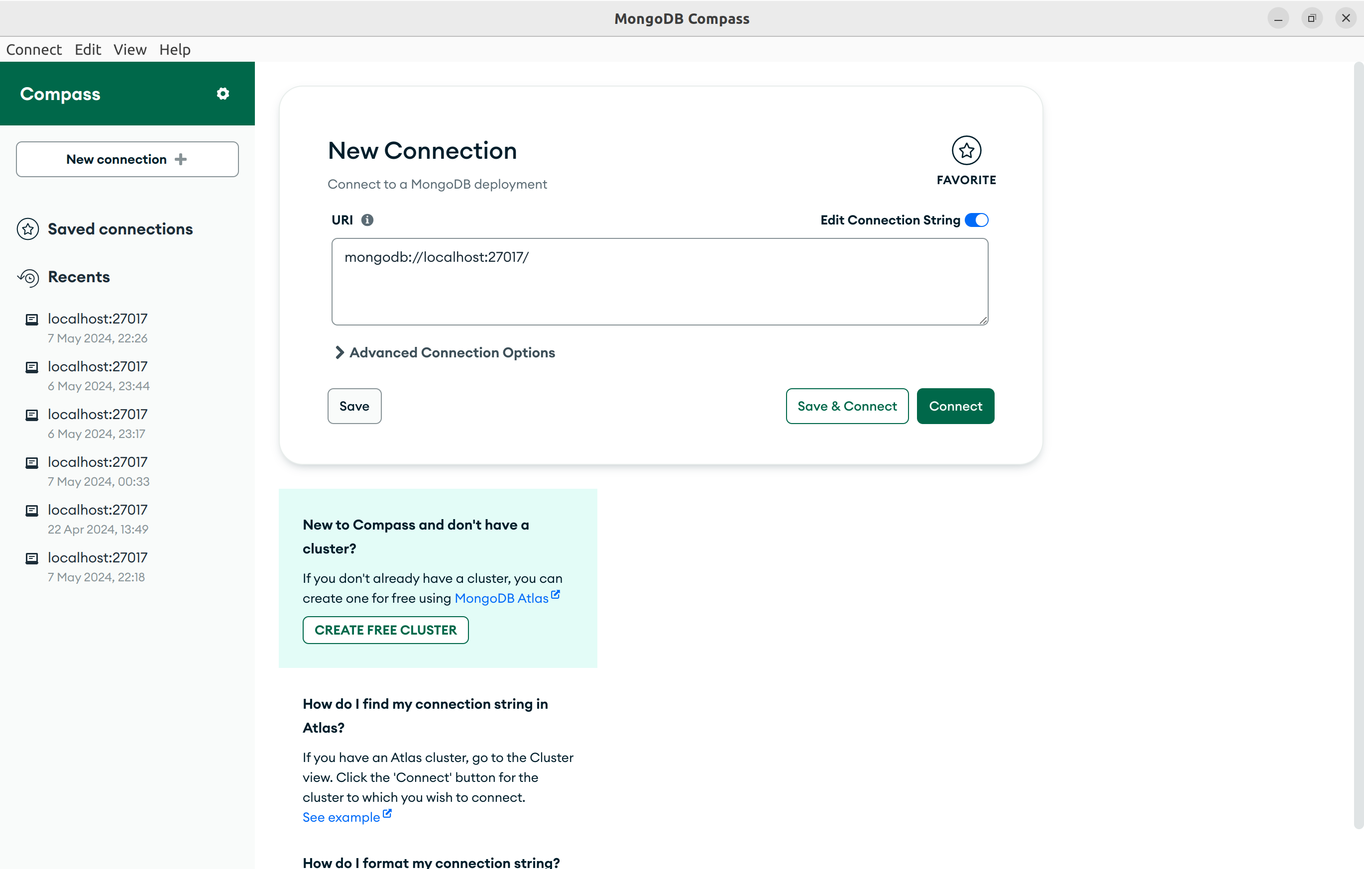

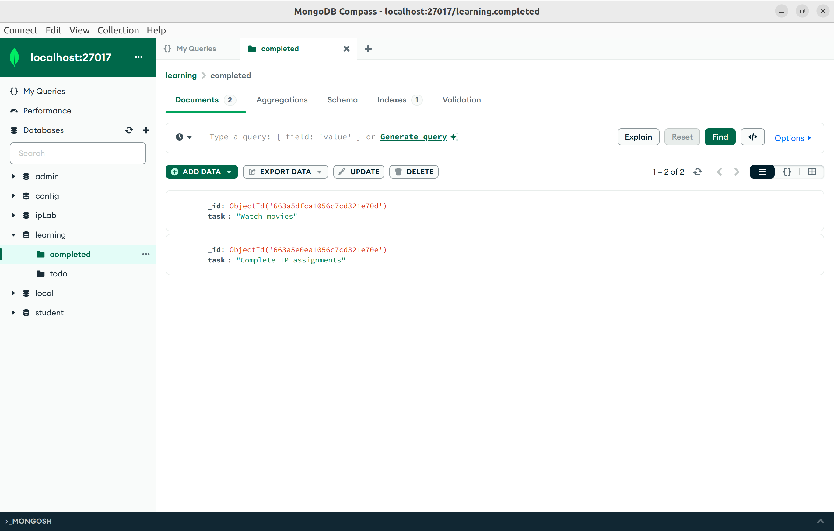

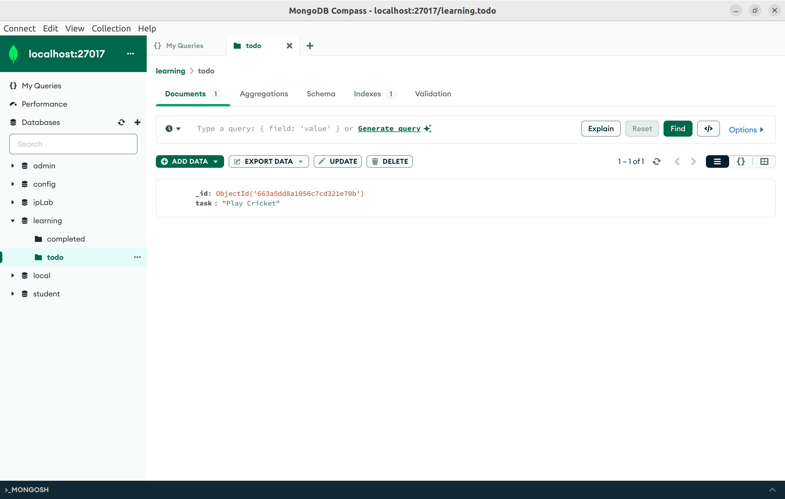

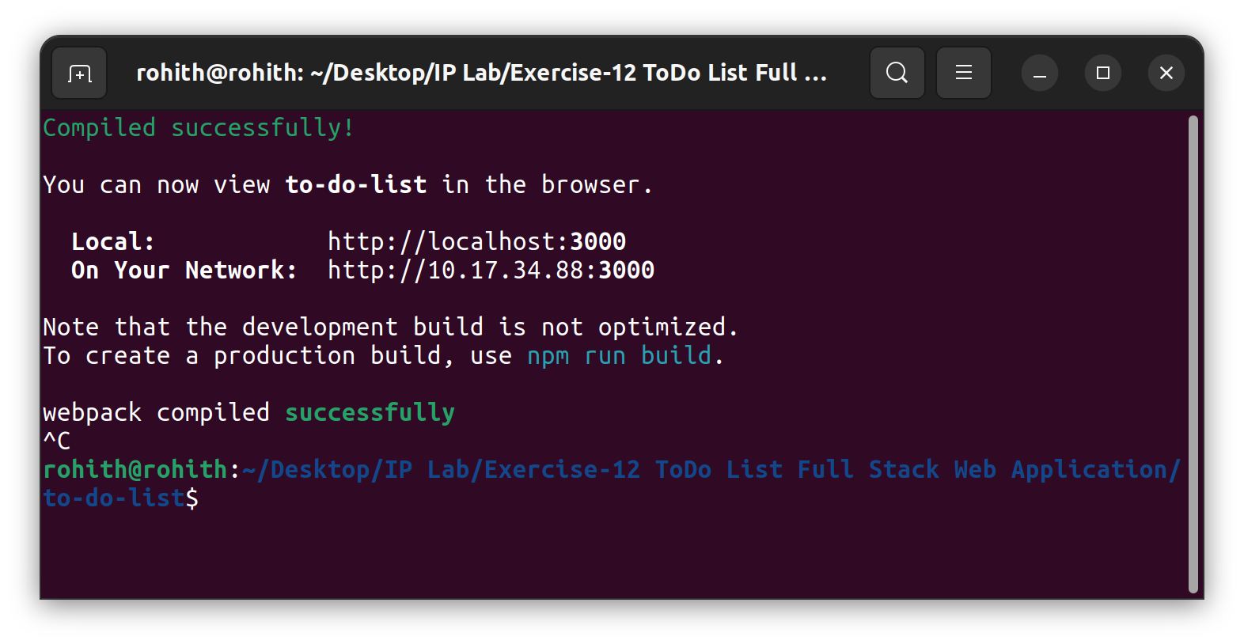

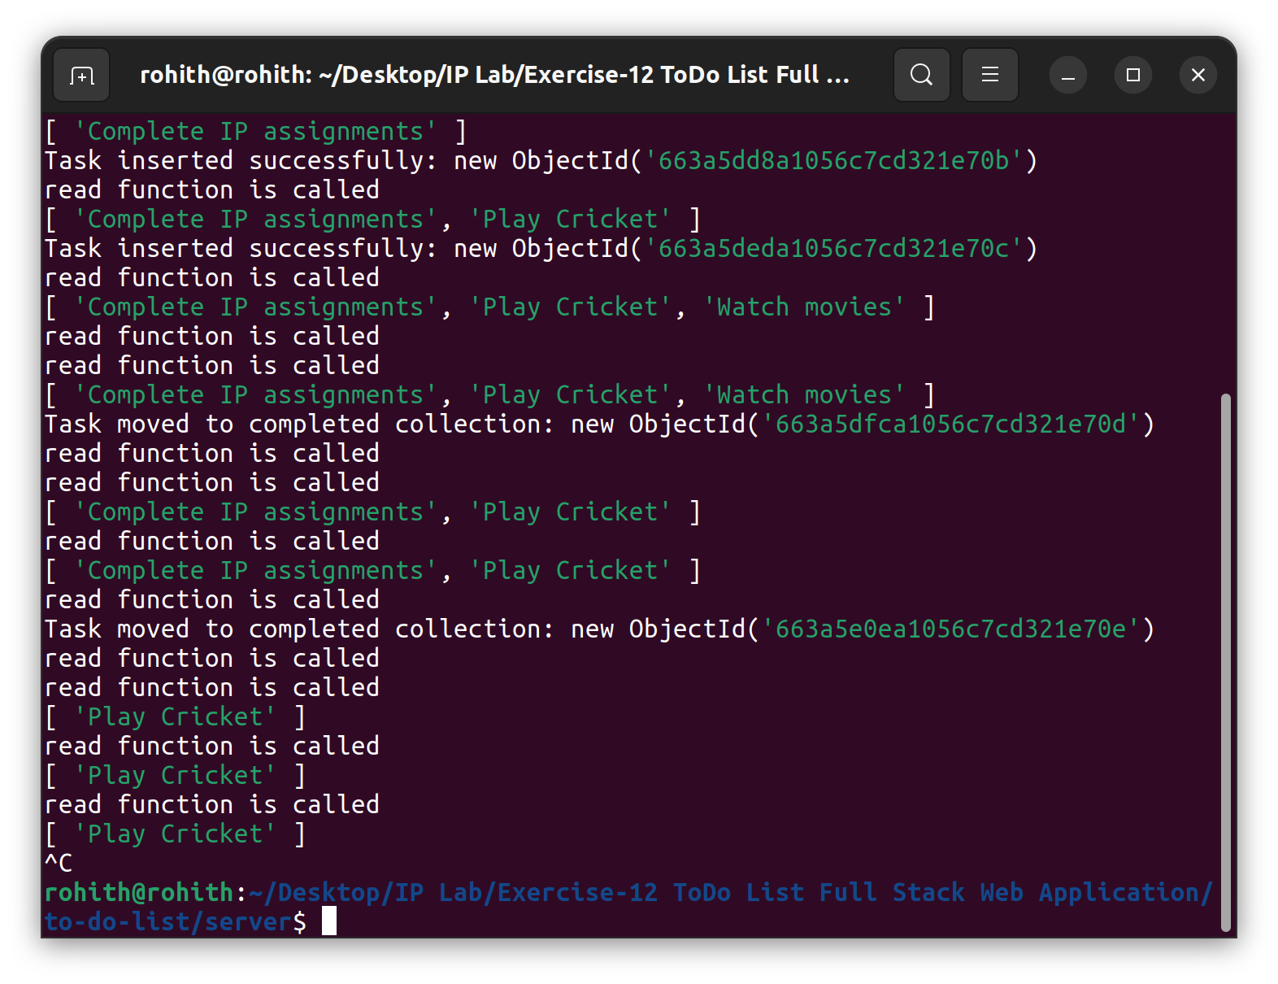

Now running the todolist application again,
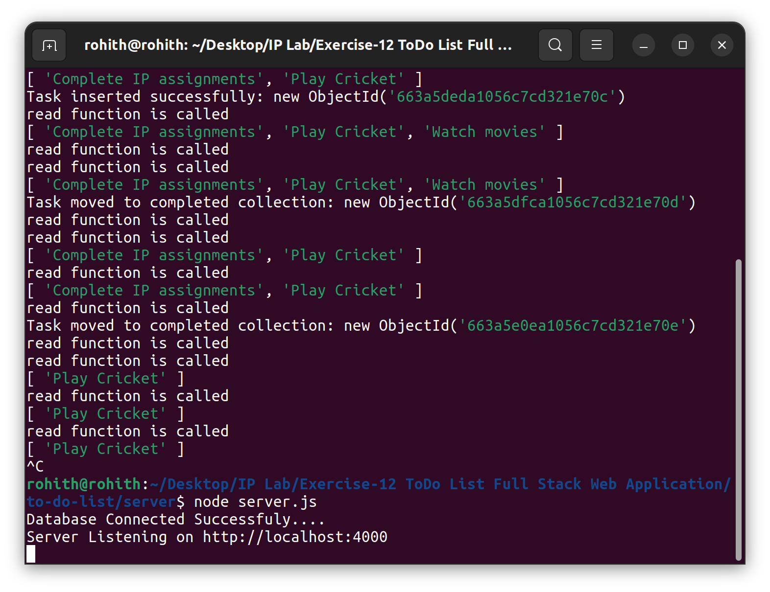
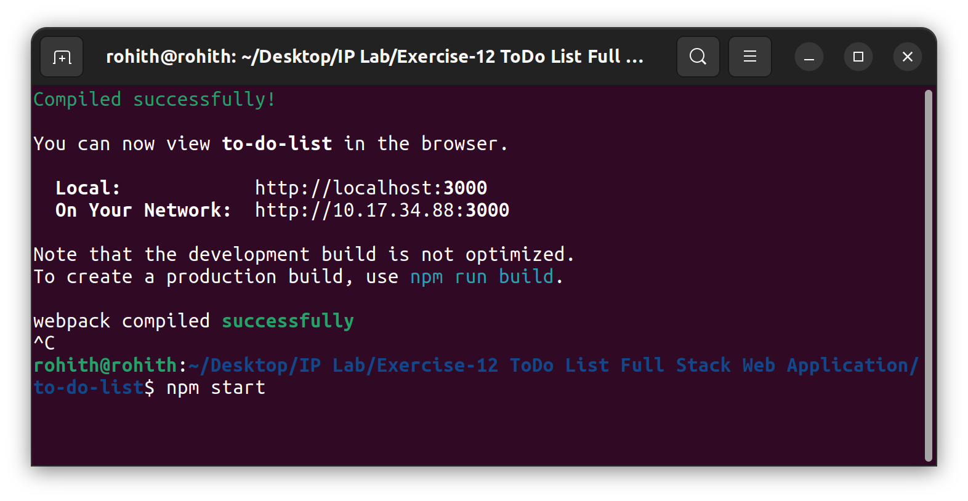

Previous data from the MongoDB Compass is retained. In order to modify it, you can delete the data from the MongoDB Compass and reload the webpage.

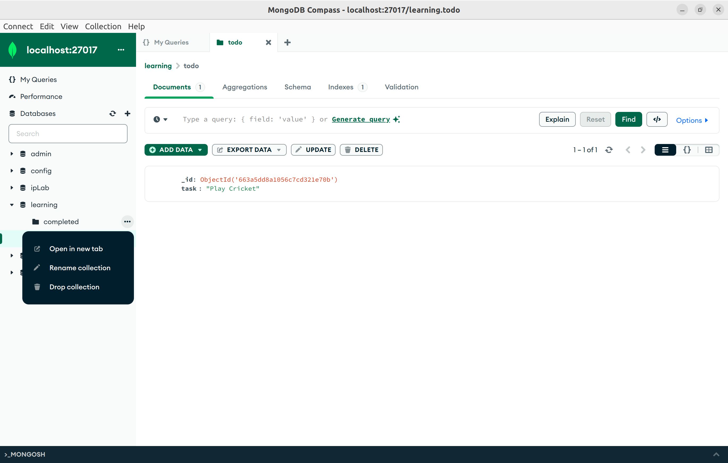

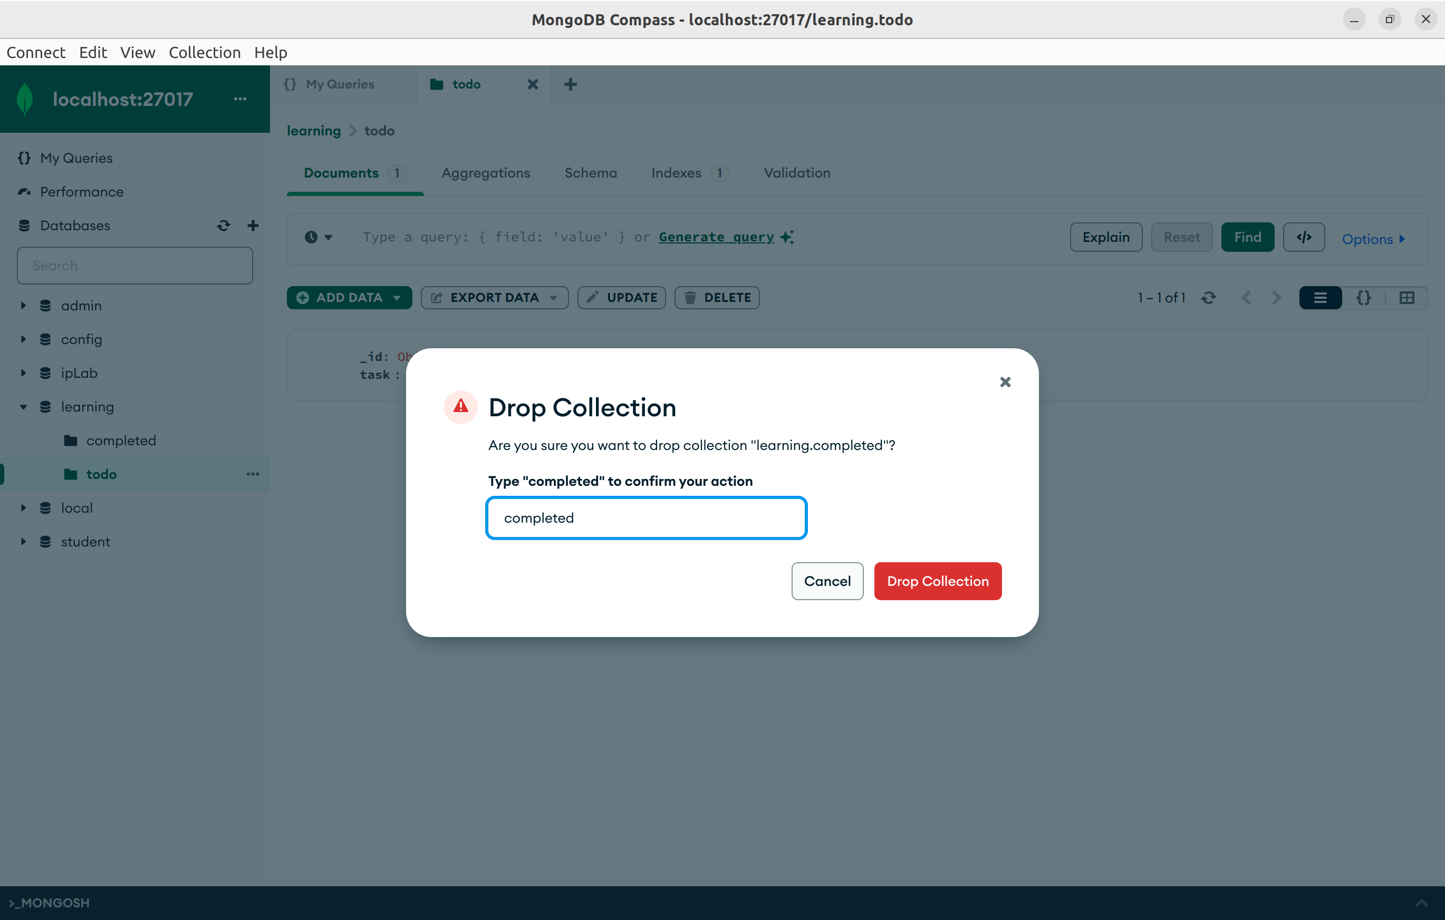

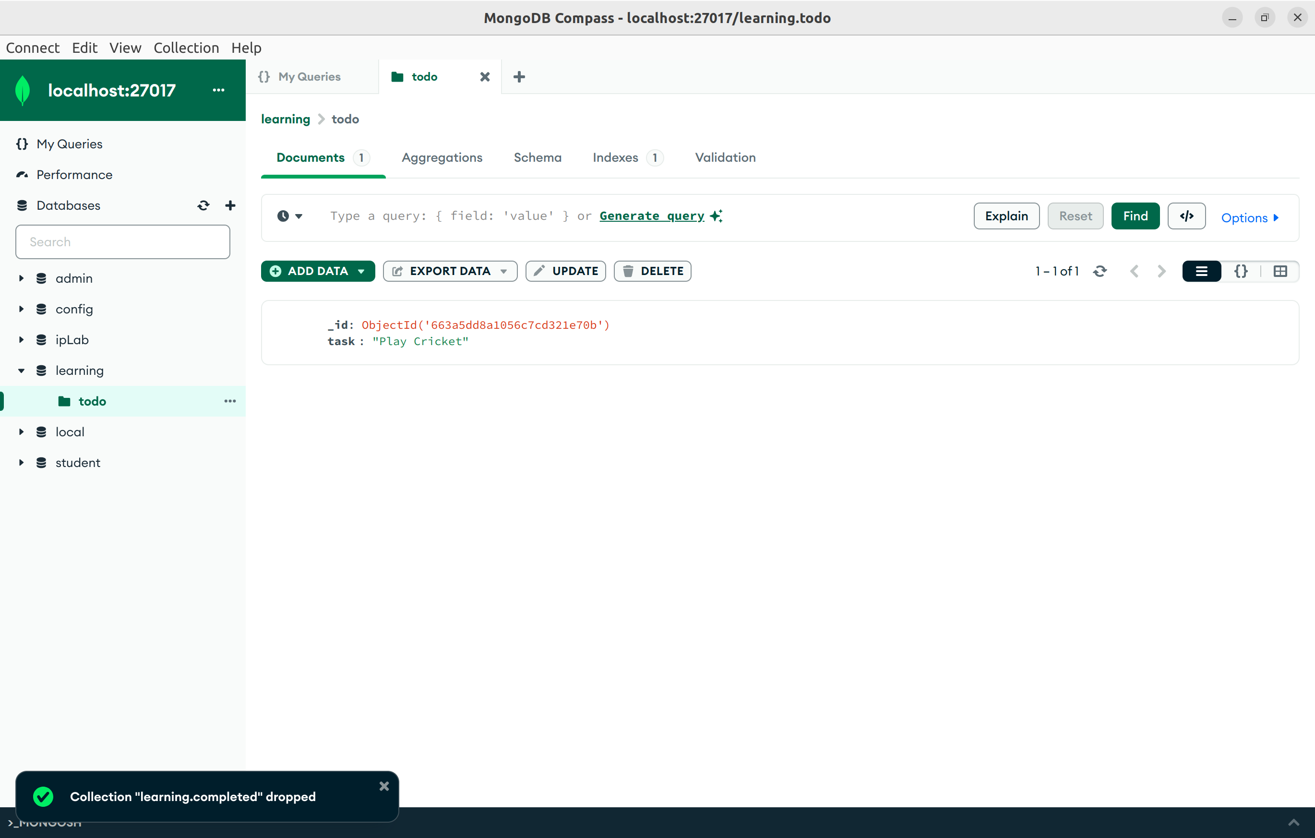

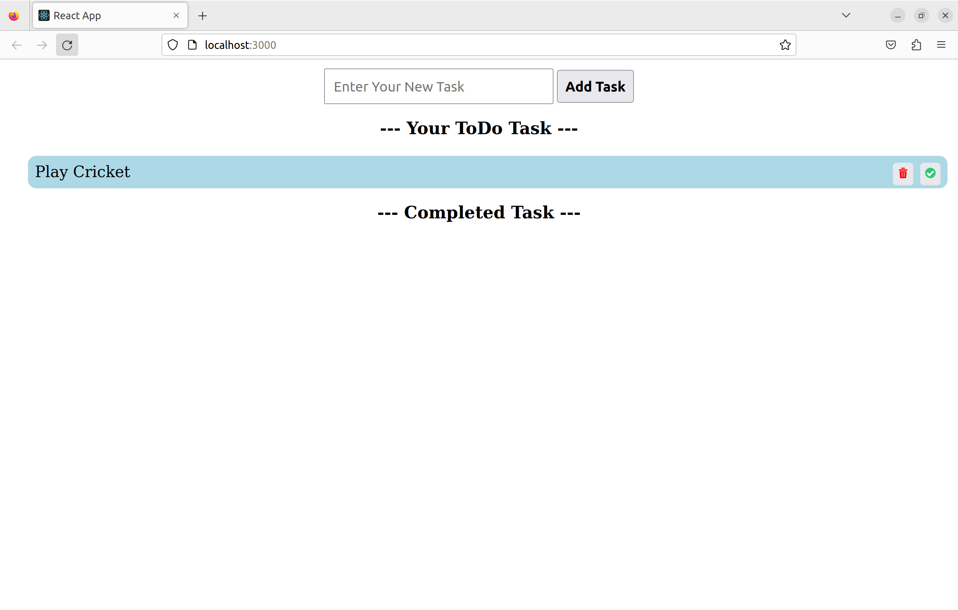
Now “LMS Assignments done” task is added using Add task button, then marked as completed.

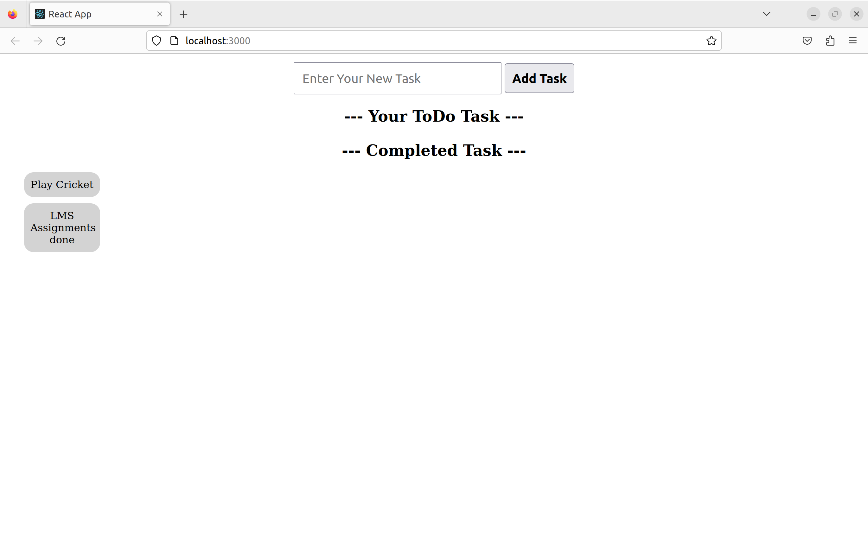

Now refresh the MongoDB Compass Database to check the modified data.

